Defuse the Bomb A CSC 102 Project
Team Group Members: Jake Calderon, John Krikorian, Declan Lustenberger, Chevaughn Hanson
BOMB DEFUSAL MANUAL
The Game This project is based on the game Keep Talking and Nobody Explodes [1], a cooperative bomb defusing party game. As the game designers put it, “You’re alone in a room with a bomb. Your friends, the 'Experts', have the manual needed to defuse it. But there’s a catch: the Experts can’t see the bomb, so everyone will need to talk it out – fast! Put your puzzle-solving and communication skills to the test as you and your friends race to defuse bombs quickly before time runs out!”
Their version is a software game. Our version takes the idea and realizes it as a physical device with buttons, switches, and more! Although our version can be played just like theirs, players can interact with both the bomb and this document at the same time (i.e., players can both defuse the bomb and serve as the “Experts”, using this document to help disarm the phases).
The backend of our version of the game is a Raspberry Pi [2] computer that combines a typical computer with the ability to interact with the outside world through sensors. The underlying software is written in Python [3] and is the result of a final group-based project in CSC 102 (The Science of Computing II) in the Computer Science Program at the University of Tampa.
Story Synopsis: Indiana Jones is scavenging the Serengeti for Priceless Artifacts when he comes face-to-face with his first deadly challenge, a booby-trapped Bomb. As he looks for a way to defuse the bomb, a countdown begins. Time is running out, and Jones is faced with an ultimatum, stay and defuse the bomb, or run for the hills.
Defusing Bombs: The bomb will “explode” when its countdown timer, which starts at exactly 300 seconds (5 minutes), reaches 0:00 or when too many strikes have occurred. You defuse the bomb by disarming all its “phases” before the countdown expires.
Phases: The bomb has 3 phases (Keypad, Wires, and Toggles), each of which must be disarmed to defuse the bomb. The phases can be disarmed in any order. Once a phase is disarmed, it becomes inactive and changing it doesn't affect the bomb. Instructions for disarming the phases are provided in this document.
Strikes: When the bomb defuser makes a mistake, a strike will be taken away from the display on the screen. After 4 strikes the bomb will explode. Additionally, each strike removes 15 seconds from the countdown timer.
Information A different version of the bomb is randomly presented each time it is “booted”. There are 6,720 unique versions of the bomb with a whopping 1,176,000 possible variations! Disarming some phases will require specific information about the bomb. Pay close attention to the “bootup” text on the bomb's screen.
Regarding the Keypad (Phase 1)
To disarm the Keypad phase, you must translate a numerical value into its binary equivalent.
- Observe the screen. A random number between 1 and 100 will appear on the display labeled “KEYPAD ENCRYPTION KEY”.
- Determine the correct binary representation of that specific number.
- Enter the correct binary code using the keypad to successfully disarm this phase. Warning: entering the incorrect binary number will result in a strike.

Regarding the Wires (Phase 2)
To disarm the Wire phase, you must analyze the image module presented to you to determine the correct pulling sequence.
- The screen will randomly display one of several wire module colors.
- Look at the "INDICATOR" section in the top right corner of the image shown below. It displays a table regarding the correct sequence in which the wires should be pulled corresponding to the color of the wire module.
- The wires on the bomb are positioned from left to right as 1, 2, 3, 4, and 5 respectively. Warning: Do not pull the wrong wire. Each mistake counts as a strike.
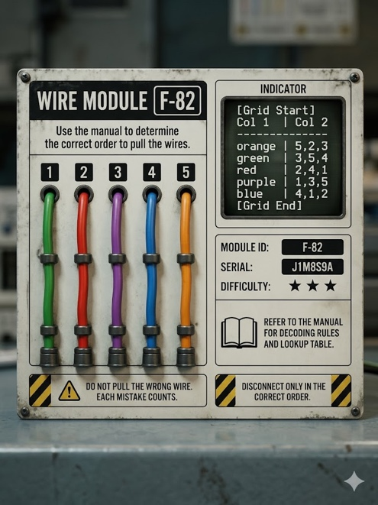

Regarding the Toggles (Phase 3)
To disarm the Toggle phase, you must decode visual signals to manipulate a series of switches.
- The bomb features four toggles, defined from left to right as positions 0, 1, 2, and 3 respectively.
- Observe the LED button. The system will use morse code combined with specific colors to give you clues regarding which toggle needs to be flipped.
- Diffuse the correct toggle based on the Morse/Color clues.
- Move to the next morse code sequence and repeat the process until all are successfully configured.
- If an incorrect switch is flipped at any point, the defuser must restart from the first morse code sequence. Warning: flipping an incorrect switch will result in a strike.
MORSE CODE SEQUENCES:
*NOTE: Red flashes indicate dashes (-) Blue flashes indicate dots (.)*
0 = . - - -
1 = . . - -
2 = - . . -
3 = - - . .
Once all three phases have been successfully disarmed, you have successfully defused the bomb!

